Welcome!
Date
Name
Spouse
Address
City
State Zip _________
Email

Please Contact By
❑ Card  Phone  Visit

Telephone Best Time to Call
Home ______________
Work ______________

Guest: First Time Second Time
Are you a church member: yes no
Church
City, State

Circle Appropriate Age/Grade Group(s)
Preschool: Ages: B-1 2-3 4-5
Children: Grades: K 1 2 3 4 5 6
Youth: Grades: 7 8 9 10 11 12
Adults: Ages:18-29 30s 40s 50s 60s+

How did you learn about our church?
Newspaper Friend Yellow Pages Mail
Other

I am a guest of:

New in the Community? Yes No
Names & ages of children at home

Weekly Service & Activity Schedule

July 12, 2015

9:45 a.m. Sunday School
11:00 a.m. Worship Service
6:00 p.m. Evening Worship/Business Meeting

Week of July 12, 2015

Wednesday 7:00 p.m. Adult Prayer & Bible Study

Upcoming Events
July
23………………………………….…………Adult Fellowship
26-30…………………………………..Vacation Bible School
August
9………………………….…………………Business Meeting
13……………………………………..……..Adult Fellowship
27……………………………………………Adult Fellowship


July 26-July 30
6-830 pm

Start spreading the word!!! Psalm 30:21 says, “And your ears shall hear a word behind you, saying, “This is the way, walk in it,…” Come join us as we take that “Journey off the Map”

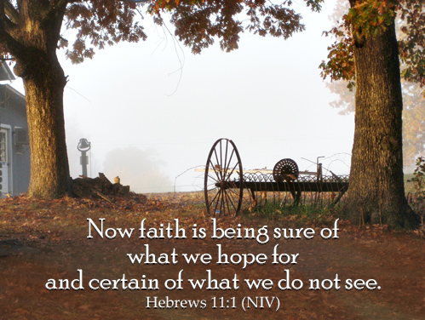

Knobbs Springs Baptist Church

July 12, 2015

Church Information:

KnobbsSpringsBC.com KnobbsSpringsBaptist@gmail.com
1662 CR 305, McDade, Texas 78650 512-273-2743

David Atwood, Pastor Cell 512-470-5098
Home 512-856-2819
Patti Radford, Office Manager Cell 512-968-7821

